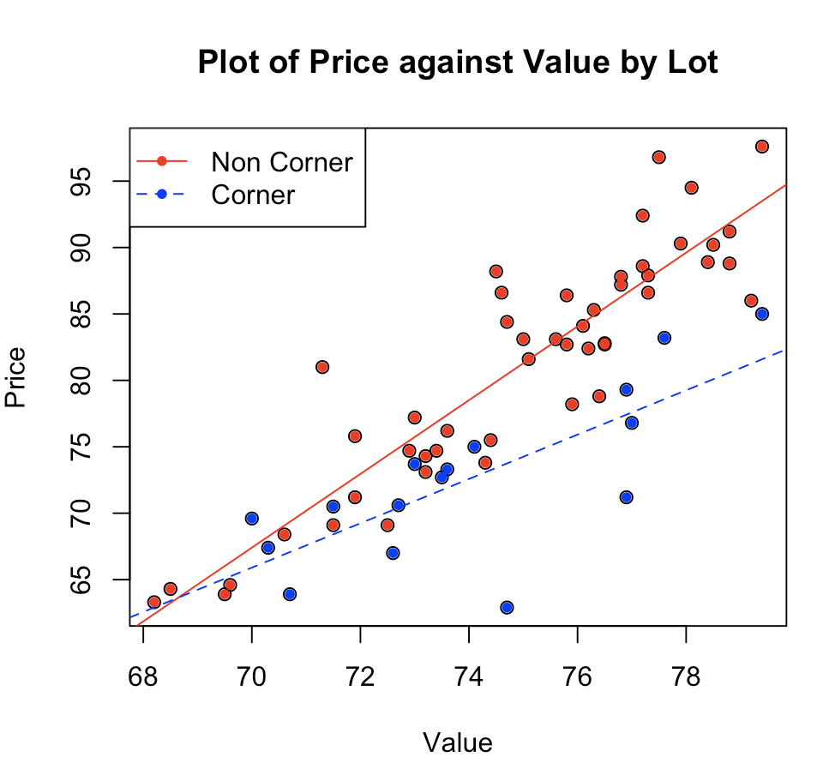Yunlu Li

STAT 5120

Homework 6

1. (a) For both Corner and Non-Corner, there seems to be a positive linear relationship between Price and Value. Since two slopes are not the same, a possible interaction should exist.

$$Price \left(non Corner\right)=-126.9052+2.7759*Value$$

$$Price \left(Corner\right)= =-50.8873+1.6684*Value$$

(b)

$$Price= -126.9052+2.7759*Value+76.0215*Lot-1.1075*Value*Lot$$

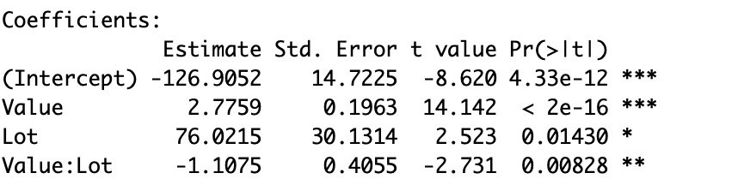

(c) The residuals fall in a horizontal band around 0, with no apparent pattern. The variance is constant. Errors are uncorrelated, and normality of error term assumption is met.

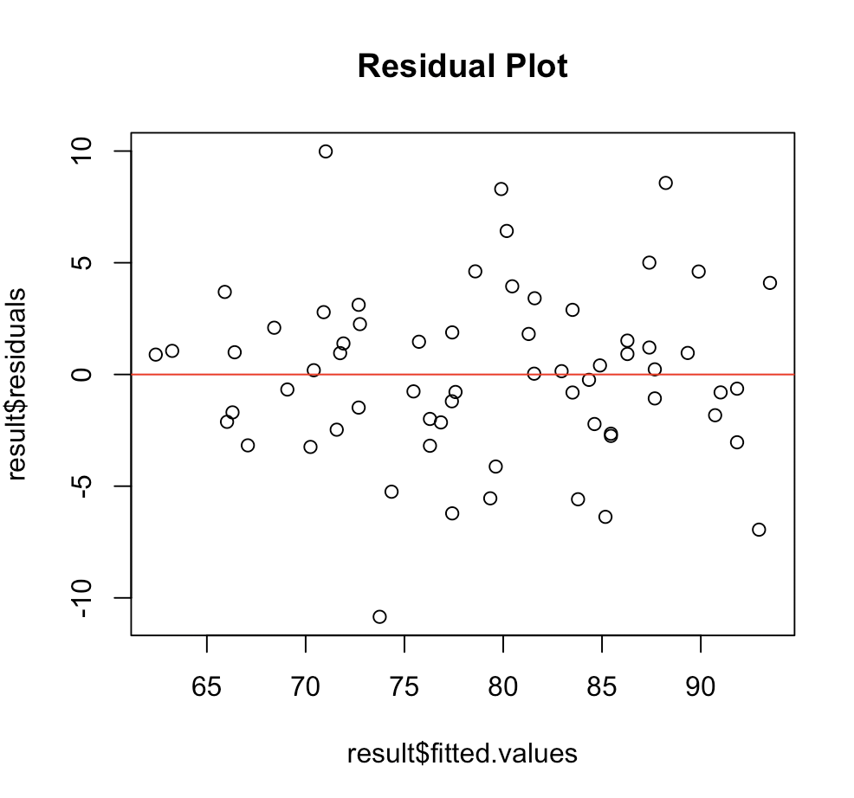 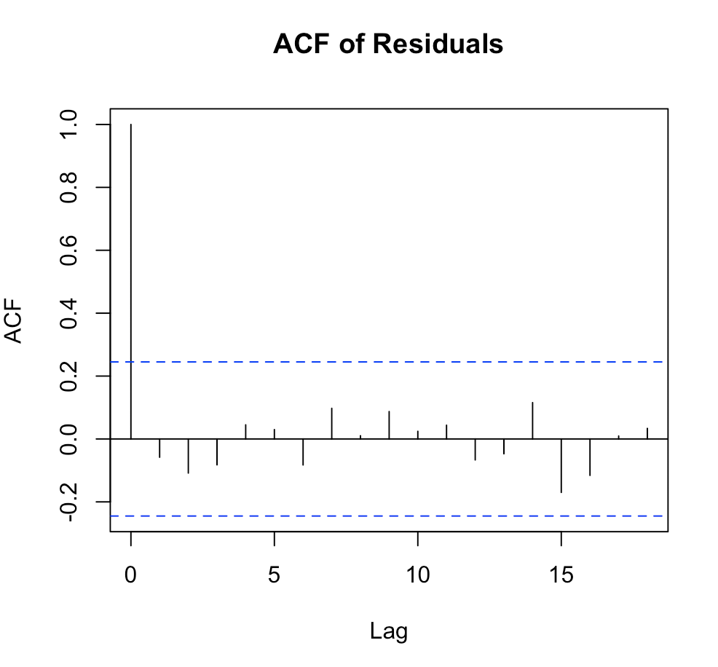 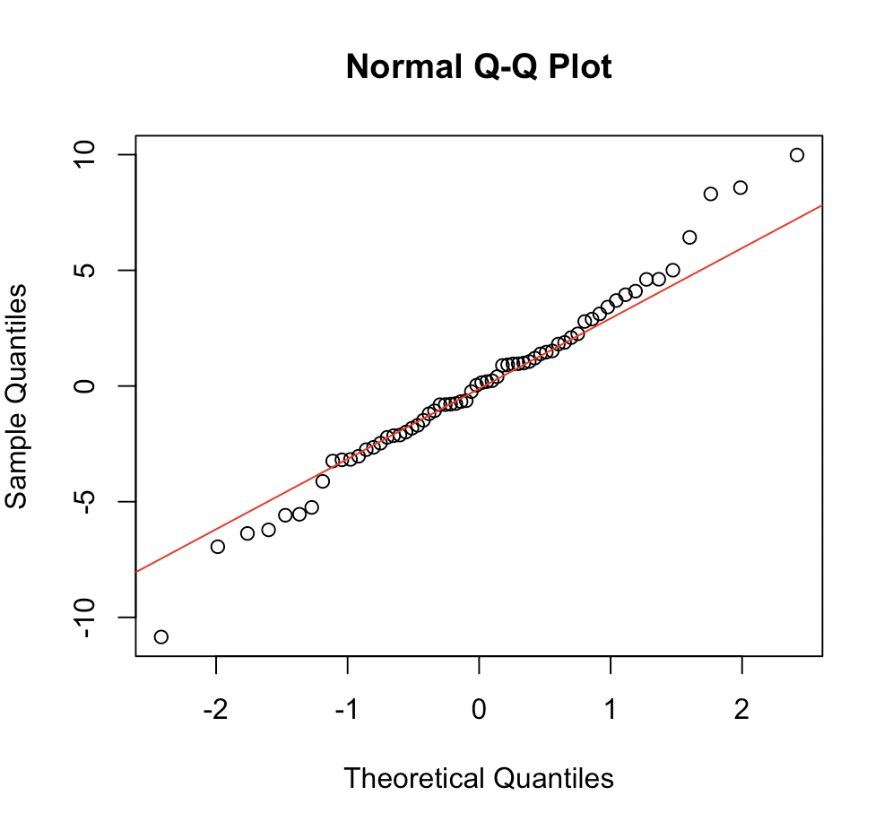

(d) Test Statistic = 2.6385, p-value = 0.1094. We fail to reject null, so we say that we have equal vairances across classes of Lot.

(e) t-statistic is -2.731 and p-value is 0.00828. The interaction term is statistically significant.

(f)

For Corner

$$Price= -126.9052+2.7759*Value+76.0215*1-1.1075*Value*1$$

$=-50.8873+1.6684*Value$

For Non-Corner

$Price= -126.9052+2.7759*Value+76.0215*0-1.1075*Value*0$

$=-126.9052+2.7759*Value$

(g) When assessed value is 70, price of Corner = -50.8873+1.6684\*70 = 65.9043 and price for non-Corner = -126.9052 + 2.7759\*70 = 67.4078. The difference is 1.5035.

When assessed value is 80, price of Corner = -50.8873+1.6684\*80 = 82.5883 and price for non-Corner = -126.9052 + 2.7759\*80 = 95.1668. The difference is 12.5785.

(h) As the valuation changes, the difference in price of Corner and non-Corner changes. This means the interaction exists.